Efficacy of borides in grain refining Al-Si alloys

Leandro Bolzoni^{1,2,}*, Nadendla Hari Babu²
^{1,2}Waikato Centre for Advanced Materials (WaiCAM), The University of Waikato
Private Bag 3105, Hamilton 3240, New Zealand
²BCAST, Brunel University London, Kingston Lane, Uxbridge, UB8 3PH, United Kingdom

Corresponding author. Tel. +64 7 837 9381 Fax. +64 7 838 4835
E-mail address: leandro.bolzoni@gmail.com (L. Bolzoni).

Abstract
The grain refining efficacy of titanium, aluminum and niobium borides, as well as niobium aluminides, introduced via commercial and lab made master alloys on Al-Si alloys was investigated. Significant grain refinement is achieved via the introduction of these heterogeneous nuclei regardless of their chemistry, stoichiometry of the master alloy, and addition rate. However, the grain refinement is affected by variable such as contact time, as the inoculating particle may sediment or be poisoned, and cooling rate. Specifically, a faster cooling rate generally leads to finer grains due to the lower time for grain growth. In the case of borides, the chemical inoculation efficiency is greatly affected by their thermodynamic stability in molten Al-Si alloys. Conversely, the grain refining potency of properitectic Al₃Nb remains unaffected. The underlying grain refining mechanism was finally investigated using current models based on the growth restriction factor Q to simultaneously consider the effect of nucleants potency and alloy chemistry. Among Ti-, Al- and Nb-based borides with similar particle size and distribution, the latter are the most efficient to grain refine Al-Si alloys.

Keywords: Grain refinement, aluminum alloys, heterogeneous nucleation, borides, solidification microstructure

1. Introduction
The control of nucleation is a fundamental aspect in many scientific disciplines such as chemical engineering, atmospheric science, plants biology and food industry as well as engineering materials like superconductors and metals. The addition of heterogeneous substrates to control and enhance the nucleation stage is a common practice known as chemical inoculation. In the case of engineering alloys, inoculation of the molten metal leading to finer grains is highly beneficial as the fluidity of the alloy increases, and the number of defects and micro- and macro-porosity decreases . The facilitated casting process is also economically important because the quality of the casting is improved and the rejection rate reduced . Chemical inoculation of Al alloys is a standard procedure and is normally done by adding Al-Ti-B master alloys, also called grain refiners. The most widely used commercial Al-Ti-B master alloys, Al-5Ti-1B in Europe and Al-3Ti-1B in U.S.A. (if not stated differently, compositions are in wt.%), contain TiB₂ particles and have Ti/B weight ratio > 2.2/1.0 and, therefore are defined as hyper-stoichiometric compositions. Excess Ti contributes to the refinement of the cast structure due to its high growth restriction factor in Al . Because of more than 60 years of development and improvement, the addition of Al-Ti-B master alloys to wrought Al alloys, when the Si content is generally < 2%, is quite optimized.
The efficacy of commercial Al-Ti-B master alloys in refining the cast structure of Al and wrought Al alloys was promoted and is well known. For the sake of simplicity, this chemical inoculation procedure was adopted for Al-Si alloys assuming that the same benefits could be obtained in shape castings such as engine blocks, wheels and pistons used in the transportation sector. Nonetheless, it has been shown that Al-Ti-B master alloys are far from being effective in refining the structure of Al-Si alloys . Research on the topic showed that Ti reacts with the Si of the Al-Si alloys forming Ti silicides, a phenomenon known as poisoning of the melt . Specifically, it was found that a layer of Ti_{x}Si_{y} is formed on top of the TiB₂ particles annihilating their ability to promote the nucleation of α-Al grains. This is due to the unfavorable lattice mismatch between Ti silicides and Al , a key factor to guarantee effective heterogeneous nucleation.
Research studies about alternative approaches investigated to effectively refine the cast structure of Al-Si alloys are available in the literature. Specifically, the effect of (i) higher addition rate of hyper-stoichiometric Al-Ti-B master alloys (i.e. Al-5Ti-1B) , (ii) stoichiometric (i.e. Al-2.2Ti-1B) and sub-stoichiometric (e.g. Al-3Ti-3B) compositions , (iii) Al-Ti-C master alloys , (iv) Al-Ti-B-C master alloys , and (v) Ti-free master alloys (e.g. Al-3B) have lately been investigated. Nevertheless, as the problem is related to the reactivity of Ti, approaches (i-iv) are not intrinsically eliminating the problem. For the latter approach (v) it was found that the Al-3B master alloy performs very well if the Al-Si alloys are Ti-free ; however, this is almost never the case for commercial Al-Si alloys where Ti is always present as impurity (~0.1%). When the Ti content is > 0.04%, Al-B master alloys have similar behavior to Al-Ti-B master alloys (i.e. Al-5Ti-1B and Al-3Ti-3B) because AlB₂ is less stable than TiB₂ in the Al melt .
We recently reported that the cast structure of Al-Si alloys can efficiently be refined via inoculation by means of Nb+B addition and, as a consequence of the low yield of Nb and B recovery, we focused on the performance of a master alloy with Al-2Nb-2B nominal composition produced at lab scale . By means of a comparative study, in this work we address the following unresolved issues about the grain refinement of commercial Al-Si alloys: (i) effect of stoichiometry and addition rate of Al-Ti-B master alloys, (ii) effect of the addition and addition rate of Al-B master alloys, (iii) effect of addition of Al-Nb master alloy, (iv) effect of the use of different borides (i.e. TiB₂, AlB₂ and NbB₂) and (v) effect of the processing conditions such as contact time and cooling rate. The aim of our work is to present and discuss the potentials and limitations of chemical inoculation considering the most critical variables affecting the performances and efficacy of the different method available to refine the cast structure of commercial Al-Si alloys on the basis of currently available models.

2. Experimental Procedure
2.1 Materials
Our comparative study was done using a commercial Sr-modified A354 alloy (Al-9Si-1.8Cu-0.55Mg-0.15Fe-0.12Ti) normally used to manufacture high performance engine blocks via sand casting (i.e. very slow cooling rate). Among hypoeutectic Al-Si alloys, the A354 was chosen as the higher the Si content the coarser the grain size and the more difficult is to refine the grain size. This gives a better idea about the intrinsic potency of the different heterogeneous nucleation substrates added. Commercial Al-5Ti-1B, Al-1.7Ti-1.7B and Al-5B master alloys were supplied by AMG, who also provided an in-house made Al-7Nb master alloy. Our Al-2Nb-2B master alloy prepared at lab scale using the procedure previously reported was also studied for comparison. Sections of the master alloys were cut and prepared for metallographic analysis using the standard methodology: grinding plus polishing with OPS. Microstructural analysis was done either using a Carl Zeiss Axioskop-2 MAT optical microscope or a Zeiss SUPRA 35VP FEG-SEM. The latter was also employed for the analysis of deep-etched sections of the master alloys. TEM samples were manually ground to roughly 60 μm in thickness and further thinned using a ion polishing equipment (5 kV, incident angle of 6º) while the analysis was done on a JEOL 2200F-TEM operated at 200 keV. The details of the materials and variables considered in this study to quantify the "effect of heterogeneous nucleation substrates" are listed in Table 1.

Table 1. Details of the materials and variables considered in this study to quantify the "effect of heterogeneous nucleation substrates".
Material | Designation | Addition rate | Fading | Effect of cooling rate
A354 (0.12% Ti) | Reference | – | ✓ | ✓
Al-5Ti-1B | Al-5Ti-1B | 0.1% Ti | ✓ | –
Al-1.7Ti-1.7B | Al-1.7Ti-1.7B | 0.05% Ti | – | ✓
Al-1.7Ti-1.7B | Al-1.7Ti-1.7B | 0.1% Ti | ✓ | ✓
Al-5B | Al-5B | 0.05% B | ✓ | ✓
Al-5B | Al-5B | 0.1% B | ✓ | ✓
Al-7Nb | Al-7Nb | 0.1% Nb | ✓ | –
Al-2Nb-2B | Al-2Nb-2B | 0.05% Nb | – | ✓
Al-2Nb-2B | Al-2Nb-2B | 0.1% Nb | ✓ | ✓

2.2 Inoculation experiments
The reference A354 alloy already contains 0.12% Ti (Table 1). Addition rates equivalent to 0.05% and 0.1% of the main chemical element of the master alloys were investigated (Table 1). It is worth mentioning that the standard addition rate for commercial Al-Ti-B master alloys, independently of their stoichiometry, is generally 0.0001% Ti (i.e. ~ 2 kg of Al-5Ti-1B per ton of melt). However, literature suggests to use higher addition rates for Al-Si alloys and, therefore, we investigated additions of Ti and B as high as 0.1%. The A354 alloy was melted and held at 760ºC for 1 h prior to chemical inoculation; casting into a 30 mm cylindrical steel mound (preheated at 250ºC) was done at 740 ± 3ºC. The cooling rate achieved under these casting conditions is 2ºC/s as measured by means of K-Type thermocouples . Apart from the effect of the intrinsic chemistry of the inoculating phases, the effect of contact time was also evaluated (Table 1). For that, fading experiments between 15 min and 7 h were carried out. The A354 alloy was initially inoculated with the different master alloys and after an initial manual stirring, the alloy was left to repose until the completion of the targeted contact time. 30 mm cylindrical castings from 740 ± 3ºC were then obtained. Castings solidified using a cooling rate of 0.5ºC/s were also produced to study the effect of cooling rate (Table 1). The same inoculation and casting conditions previously described were used for consistency. Samples were cast after 15 min of contact time for direct comparison.

2.3 Effect of alloy chemistry
The effect of the alloy chemistry on the grain refining capability using samples solidified at 0.5ºC/s, cast from 740 ± 3ºC without and with chemical inoculation with the previously mentioned master alloys was studied. For that, Al-Si alloys with different amount of alloying elements were considered. The chemical composition of the alloys measured via optical emission spectroscopy is shown in Table 2.

Table 2. Chemical composition of the alloys used to study the "effect of alloy chemistry".
Alloy | Alloying elements [%]
 | Si | Cu | Fe | Mg | Zn | Mn | Ti
A1 | 9.9 | – | 0.1 | – | – | – | –
A2 | 7 | 0.054 | 0.154 | 0.35 | 0.054 | 0.067 | 0.12
A3 | 7 | 0.054 | 0.154 | 0.65 | 0.054 | 0.067 | 0.12
A4 | 9 | 1.8 | 0.154 | 0.55 | 0.1 | 0.75 | 0.12

2.4 Characterization of the castings
The microstructural study carried out on the 30 mm cylindrical castings was done on the cross section located at approximately 20 mm from the bottom of the samples and at roughly half of the diameter of the cylindrical section (see inset in Fig. 1a). This is because in some materials, especially the reference A354 alloy, columnar grains were formed in the outer part of the castings upon solidification. For the same reason, the microstructural study on the castings solidified at 0.5ºC/s was done on the cross section located at 40 mm from the surface of the castings and one third of the width of the section (see inset in Fig. 1b). Classical metallographic steps were taken to prepare the cross section of the castings for grain size measurements which were performed as per the intercept method (ASTM E112). For that, samples were submerged in a HBF₄ solution and anodized using a 10V / 1A current. The opposite cross section of the castings was used for visual analysis, for which the samples were macroetched with the Tucker solution (15 ml HF + 15 ml HNO₃ + 45 ml HCl + 25 ml H₂O).

3. Results
3.1. Reference A354 Al-Si alloy
Data are available in the literature about the grain size of commercial Al-Si alloys without and with inoculation. However, variations in composition and impurity level as well as solidification conditions leads to changes in grain structure. For instance, we previously demonstrated that the superheating of Al-Si alloys has a strong effect on the size of their cast structure . Therefore, it is necessary to establish reference data (microstructure and grain size) in this work. Fig. 1 presents the variation of the grain size with contact time and cooling rate of the reference A354 alloy. It is shown that independently of the time at temperature or cooling rate, the reference alloy has a coarse dendritic structure (micrographs as inset in Fig. 1). The solidification of the A354 alloy begins by heterogeneous nucleation in the melt near the wall of the die followed by columnar growth (macrographs as inset in Fig. 1). Solute enrichment at the solidification front and reduction of the thermal gradient leads to the formation of dendritic grains in the interior of the casting. The locations where grain size measurements were performed are also highlighted. These locations and the correlated grain size (~ 1500 μm) will be taken as reference. A lower cooling rate leads to a somewhat coarser microstructure . Moreover, it can be noticed the high variability of the measurements which corresponds to highly heterogeneous non-equiaxed dendritic grains.
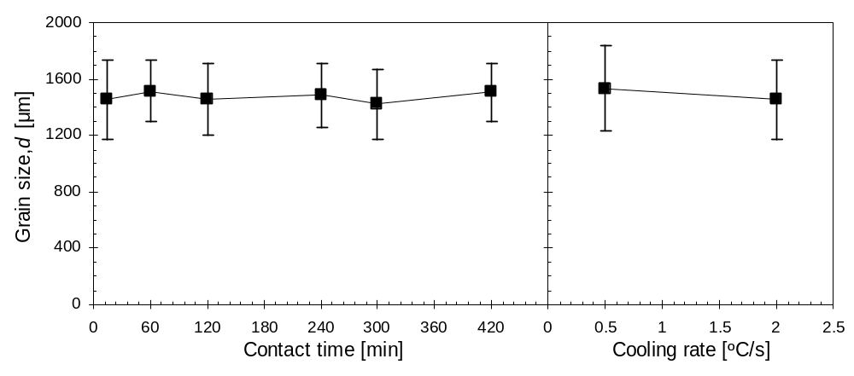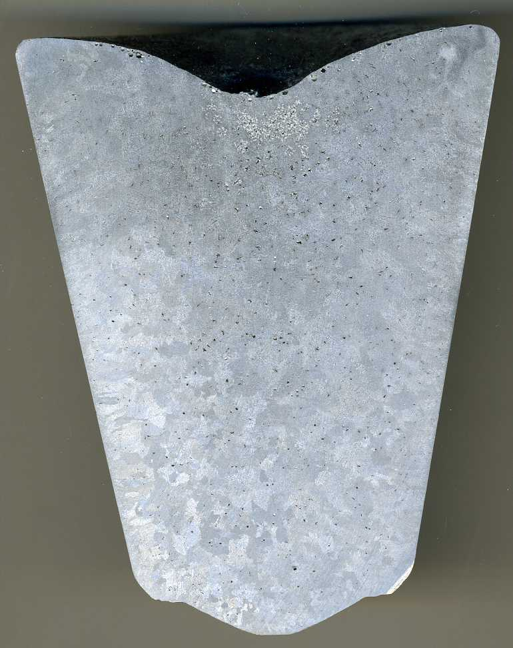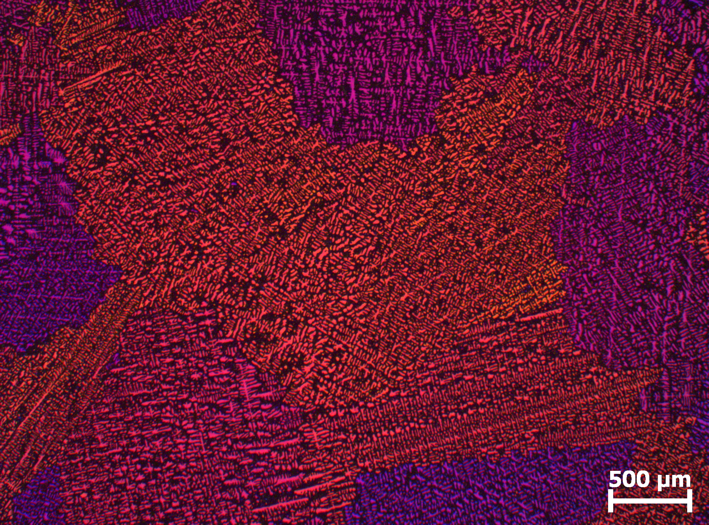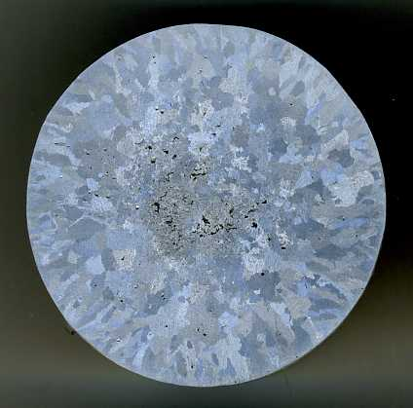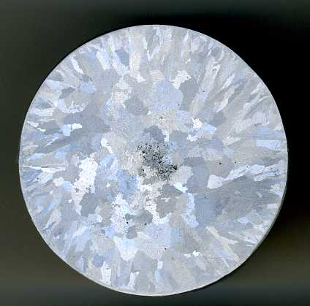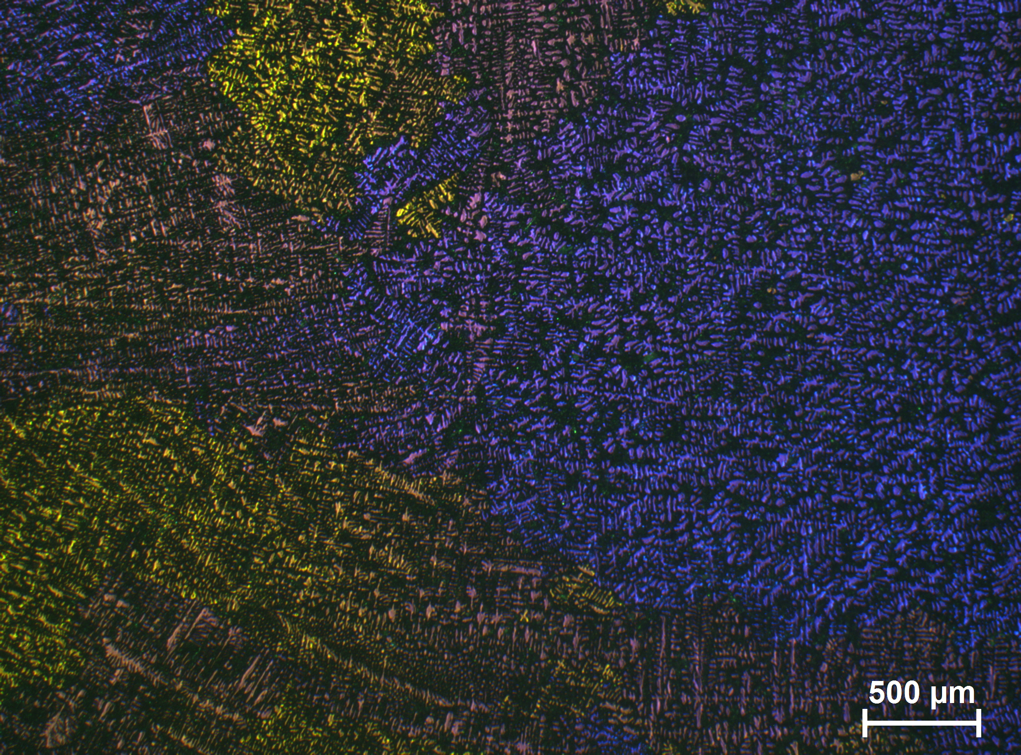
(b)
20 mm
10 mm
Columnar grains
10 mm
(a)
Fig. 1. Variation of the grain size (d) for the reference A354 alloys. (a) Effect of contact time and (b) effect of cooling rate. The cast structure of the reference is composed of dendritic α-Al grains and has columnar grains on the outer part of the castings (see macrographs as inset). The locations where the polarized light micrographs (examples as inset) for grain size measurements were taken are also labelled.

3.2. Inoculation with Ti-based master alloys
Different studies in the literature report that hyper-stoichiometric (e.g. ) and sub-stoichiometric (e.g. ) Al-Ti-B master alloys can refine the cast structure of commercial Al-Si alloys. However, comparison with data available in the literature would be influenced by other processing variables such as composition of the alloys, inoculation procedure and solidification conditions. Therefore, in this work inoculation of the A354 alloy with Al-5Ti-1B and Al-1.7Ti-1.7B was used so as to have a direct comparison of the potency of the different inoculants eliminating the effect of other variables. Fig. 2 confirms that Al-Ti-B master alloys refine, to some extent, the cast structure of Al-Si alloys. Grain sizes in the range of 200 μm are normally obtained when inoculating pure Al and wrought Al alloys with commercial Al-Ti-B master alloys. Nevertheless, from Fig. 2 it can be seen that although of the 0.1% Ti addition, inoculation of the A354 alloy initially reduces the grain size down to only ~ 800 μm. The efficacy of the substrates is completely lost after 3-5 h of contact time (Fig. 2a) due to the sedimentation and poisoning of the TiB₂ particles. Cooling rate and addition level (Fig. 2b) have a minor effect on the final cast structure. Inoculation of Al-Si alloys with Al-Ti-B master alloys does not permit to obtain a fully equiaxed structure as columnar grains are present in the castings, especially in the case of the sub-stoichiometric Al-1.7Ti-1.7B master alloy (see inset in Fig. 2). This indicates that nucleation simultaneously happened heterogeneously from the melt near the wall of the die and from the TiB₂ substrates added.
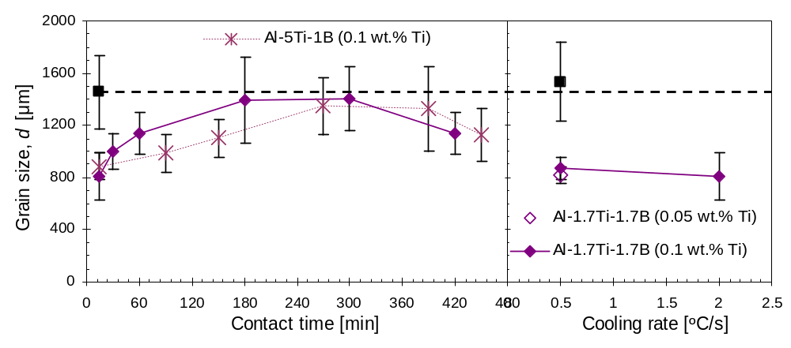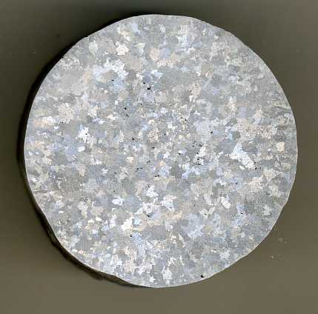
(b)
(a)
Columnar grains
Reference
0
Fig. 2. Variation of the grain size (d) for the reference A354 alloy inoculated with Ti-based master alloys. (a) Effect of contact time and (b) effect of cooling rate. Inset: photo of the macroetched samples inoculated with 0.1%Ti via Al-1.7Ti-1.7B master alloy.

3.3. Inoculation with B-based master alloy
The addition of Ti-free master alloys has been previously studied and data are available in the literature (e.g. ). It is clear that Al-B master alloys are very effective in Ti-free Al-Si alloys, such as in binary and ternary Al-Si alloys prepared by high purity materials (> 99.999%) as demonstrated by Chen et al. . Nevertheless, when Ti is present as impurity, the performances of Al-B master alloys are comparable to those of commercial Al-Ti-B master alloys . This is because TiB₂ is much more stable than Al borides inside molten Al and thus Al borides transform into Ti borides . Experiments on the inoculation of the A354 alloy with the Al-5B master alloy confirm the initial promotion of heterogeneous nucleation. Such as in the case of Al-Ti-B master alloys, the potency of the heterogeneous substrates decreases with an increase of the contact time (Fig. 3a) due to sedimentation and poisoning. The effect of cooling rate and addition level on to the size of the grains constituting the cast structure is fairly evident. The lower the addition rate (i.e. 0.05% vs 0.1%) and the lower the cooling rate (Fig. 3b), the coarser the cast structure. As for the previous case where Ti-based substrates were used to promote heterogeneous nucleation, the addition of Al-B master alloys cannot completely suppress the formation of columnar grains during solidification of Al-Si alloys (see inset in Fig. 3).
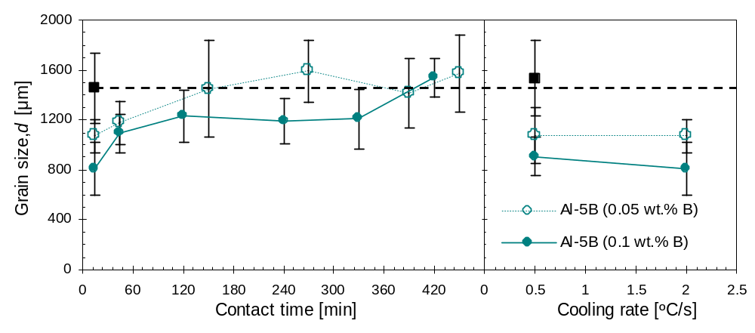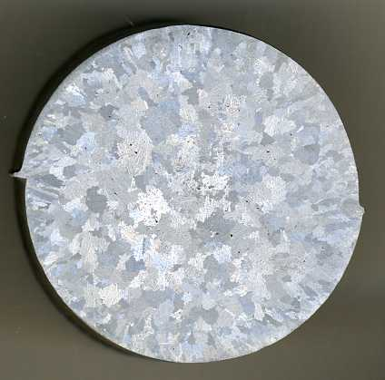
(b)
(a)
Columnar grains
Reference
Fig. 3. Variation of the grain size (d) for the reference A354 alloy inoculated with B-based master alloy. (a) Effect of contact time and (b) effect of cooling rate. Inset: photo of the macroetched samples inoculated with 0.1%B via Al-5B master alloy.

3.4. Inoculation with Nb-based master alloys
In our previous study that led to the development of Nb+B inoculation, we analyzed the effect of the addition of Nb to pure Al but not to Al-Si alloys. We show in Fig. 4 that the addition of the Al-7Nb master alloy can refine the cast structure of Al-Si alloys as much as commercial Al-Ti-B and Al-B master alloys because after 15 min the grain size is reduced to roughly 800 μm. However, conversely to the commercial master alloys, the efficacy of the Al-7Nb master alloy is not affected by how long the heterogeneous nuclei stay in contact with the molten alloy as the grain size remains stable for as long as 7 h. The grain refinement obtained by the addition of the Al-7Nb master alloy is due to the introduction of copious heterogeneous substrates as the addition rate of 0.1%Nb is lower than the maximum solubility (i.e. 0.15%Nb ). It is worth mentioning that the addition of the Al-7Nb master alloy to the A354 alloy almost completely prevents the formation of columnar grains growing in the melt from the grains nucleated near the wall of the die. A much narrower annular composed of columnar grains was present near the outer surface of the castings.
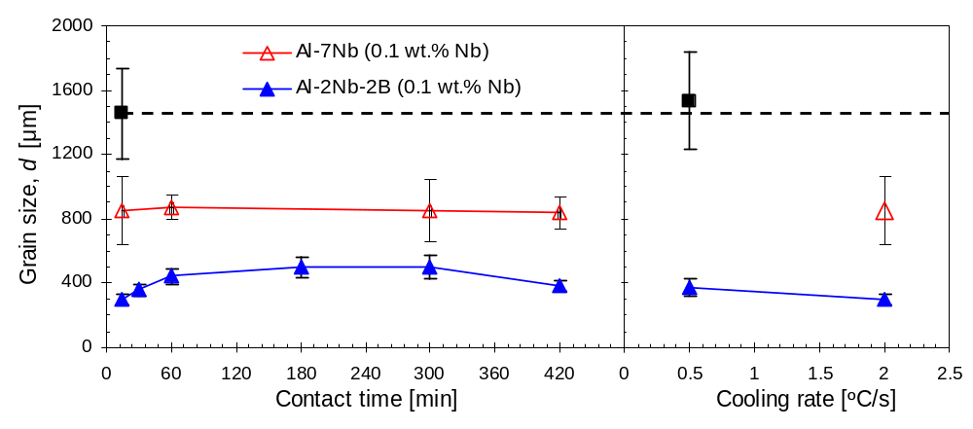
(a)
(b)
Reference
Fig. 4. Variation of the grain size (d) for the reference A354 alloy inoculated with Nb-based master alloys. (a) Effect of contact time and (b) effect of cooling rate.

The lab made Al-2Nb-2B master alloy we developed contains Nb-based substrates (i.e. Al₃Nb and NbB₂) which are isomorphous to the Ti-based substrates (i.e. Al₃Ti and TiB₂) present in commercial Al-Ti-B master alloys. The combined addition of Nb and B permits to refine the cast structure of Al-Si alloys to a greater extent as after 15 min the grain size is < 300 μm (Fig. 4a). The grain size slightly increases with the contact time and with the solidification time (Fig. 4b). Yet, the grain size of the A354 alloy inoculated with the Al-2Nb-2B master alloy is much finer and the associated standard deviation is consequently much lower (i.e. more homogeneous equiaxed grain structure). This study further shows that inoculation of Al-Si alloys with Nb-based substrates entirely suppresses the formation of columnar grains and thus the formation of the columnar-to-equiaxed transformation zone . The results shown in Fig. 4 indicates that Al-Nb-B master alloys are the most effective. As their intrinsic potency is expected to be lower, due to the less effective growth restriction of Nb, their higher efficacy is due to the higher chemical stability of Nb-based substrates with respect to Ti-based substrates and Al borides.

4. Discussion
4.1 Effect of heterogeneous nucleation substrates
Over the years different theories have been proposed to understand the grain refinement of Al: carbide-boride particle theory , the peritectic theory , the hypernucleation theory , the duplex theory , and the solute theory . Semi-empirical models based on the constitutional undercooling were also lately proposed to relate the grain size to the growth restriction factor . The free-growth model proposed by Greer at al. states that grain initiation on a potent substrate is controlled by the barrier to growth of a nucleus, which depends on the dimension of the substrate:
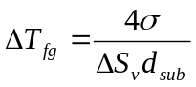 (1)
where ΔT_{fg} is the undercooling for free growth, σ is the liquid-solid interfacial energy, ΔS_{v} is the entropy of fusion per unit volume and d_{sub} is the diameter of the substrate. Thus, the size of the substrate is critical for the formation of new grains where the largest particles become active nucleants at lower undercoolings.
Fig. 5 shows representative results of the characterization of the master alloys used in this study. Full characterization of commercial Al-Ti-B master alloys has been previously reported . Blocky Al₃Ti and a fine dispersion of hexagonal platelets TiB₂ particles is generally found where for the latter particles below 0.2 μm and above 6.0 μm in diameter are barely present. Within this range, especially for diameters >1 μm, the population distribution can be well fitted by an exponential function: y=y₀ exp(-d/d₀) . The features (type, morphology and size of the particles) of the Al-Ti-B master alloys was confirmed via SEM analysis (Fig. 5a) and fully justifies the fading of the grain refining potency of the Ti-based heterogeneous substrates shown in Fig. 2.
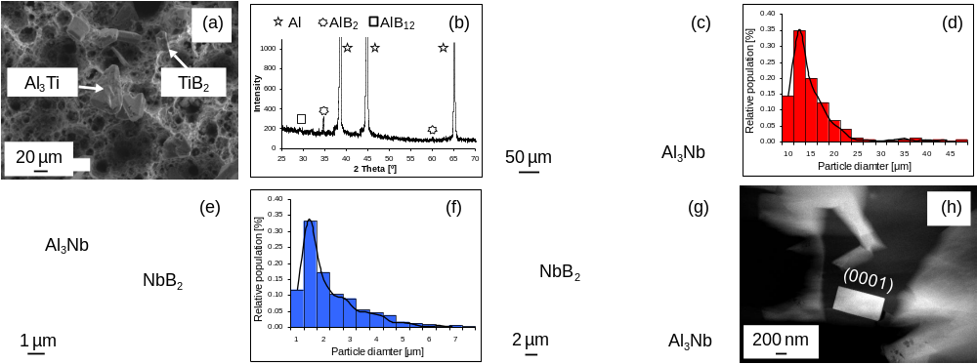
Fig. 5. Representative results of the characterization of the master alloys used. (a) SEM micrographs showing the particles present in the Al-Ti-B master alloys; (b) XRD pattern of the Al-5B master alloy; (c) Optical micrograph showing the distribution of the particles present in the Al-7Nb master alloy; (d) Size distribution of the Al₃Nb particles found in the Al-7Nb master alloy; (e) SEM micrograph showing the particles present in the Al-2Nb-2B master alloy; (f) Size distribution of the particles present in the Al-2Nb-2B master alloy; (g) SEM micrograph showing the morphology of the particles of the Al-2Nb-2B master alloy; (h) HAADF-STEM micrograph of NbB₂ particle present in the Al-2Nb-2B master alloy showing the (0001) basal plane.

Al-B master alloys have also previously been extensively characterized . AlB₂ particles are generally predominant but the high temperature AlB₁₂ phase could also be present if the Al-B master alloys have been produced at temperatures lower than the peritectic reaction temperature . AlB₂ and AlB₁₂ particles have hexagonal close packed and tetragonal crystal structures with a = 3.006 Å and c = 3.252 Å and a = 10.161 Å and c = 14.238 Å lattice parameters, respectively . The size and distribution of the particles is comparable to that of the TiB₂ particles found in Al-Ti-B master alloys and AlB₂ and AlB₁₂ are present in the Al-5B master alloys (Fig. 5b). As the A354 alloy used in this study has 0.12% Ti (see Table 1) and Ti borides are more thermodynamically stable than Al borides, Al borides will progressively dissolve once the A354 alloy is inoculated with Al-5B (fading in Fig. 3).
The Al-7Nb master alloy is characterized by a uniform dispersion of polygonal Al₃Nb particles (Fig. 5c). The mean particle size of these properitectic particles is coarser in comparison to those found in the commercial master alloys (Fig. 5d). Al₃Nb intermetallic particles form peritectically in liquid Al (and for 7% Nb they are stable up to approximately 1580ºC ) and are thus the heterogeneous substrates responsible for the grain refinement achieved. This study demonstrates and confirms that Al₃Nb particles are stable at temperature normally used in Al foundries and have the ability to refine the grain structure of Al-Si alloys (Fig. 4).
Microstructural analysis confirms that stable heterogeneous substrates, with a particle size distribution from sub-micrometric (0.5 μm) to micrometers (~10 μm), are present in the lab made Al-2Nb-2B master alloy and their dispersion and distribution is rather uniform. SEM analysis indicates that two types of Nb-based compounds are present, NbB₂ and Al₃Nb as confirmed by EDS semi-quantitative analysis, and the compounds are actually agglomeration of various particles as outcome of the liquid engineering manufacturing method used to produce the Al-2Nb-2B master alloy . Although found in the concentrated Al-2Nb-2B master alloy, the particles disperse once added to the molten metal. SEM morphological analysis carried out in deep-etched Al-2Nb-2B master alloy samples and TEM investigation confirm the expected hexagonal (NbB₂) and tetragonal (Al₃Nb) crystal lattices as shown in Fig. 5g where Al₃Nb particles nucleated onto the surface of a NbB₂ particles. High angle annular dark field (HAADF) scanning transmission electron microscopy further confirmed the chemistry and morphology of the Nb-based heterogeneous substrates. Of particular interest is the (0001) basal plane of the NbB₂ compounds (see Fig. 5h) which is the one with the lowest lattice mismatch and the most favourable orientation relationship to promote heterogeneous nucleation of α-Al grains as well as Al₃Nb crystals. The lattice constants for NbB₂ and for Al₃Nb are a = 3.102 Å and c = 3.285 Å and a = 3.8485 Å and c = 8.615 Å, respectively .
The heterogeneous substrates added into the A354 alloy via the Ti-based, B-based and Al-2Nb-2B master alloys have comparable size and distribution. Assuming that the liquid-solid interfacial energy and the entropy of fusion do not significantly change, from Eq. 1 the ΔT_{fg} for the free growth of grains is similar for the different inoculants used. The comparison of the grain refinement achieved is done in Fig. 6a where the best performance of each master alloy and addition rate, which in every fading experiment corresponds to the shortest inoculation time of 15 min, is presented. The Al₃Nb particles present in the Al-7Nb master alloy have bigger size which means that the nucleation of the primary α-Al grains commences at lower undercooling. As the grain refinement performance is dominated by the largest particles , the inoculation of the A354 alloy via an Al-Nb master alloy with Al₃Nb particles whose size is comparable to that of the other master alloys would require larger undercooling. On the basis of Spittle’s works , a more straightforward comparison of the grain refining potency should be done considering a common element rather than the addition rate (Fig. 6a) as the latter could lead to misjudgments.
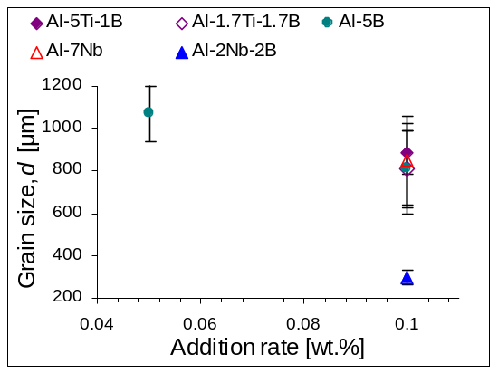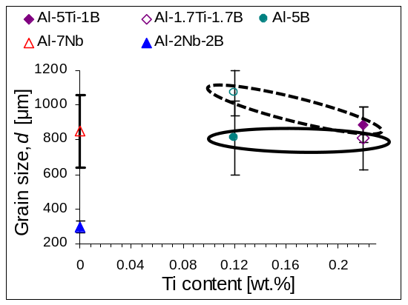
(a)
(b)
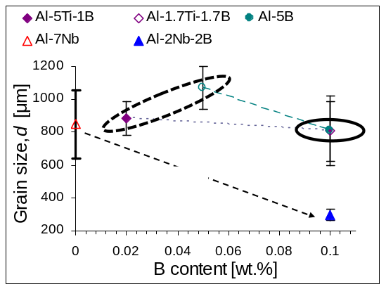
(c)
Fig. 6. Comparison of the inoculation efficacy of the different master alloys. (a) Variation of the grain size (d) with the addition rate; (b) Variation of the grain size (d) with the Ti content; and (c) Variation of the grain size (d) with the B content.

The A354 alloy used in this study already contains ~0.12% Ti and all the master alloys, with the exception of the Al-7Nb, contain B; therefore, both elements could theoretically be used for a more sensible comparison. The variation of the grain size with the Ti and B contents is plotted in Fig. 6b and Fig. 6c, respectively. The former permits to highlight the effect of the stoichiometry of the master alloys as the addition of 0.05% and 0.1% via the Al-5B master alloy results in Ti/B ratios of 2.4 (hyper-stoichiometric) and 1.2 (sub-stoichiometric) respectively. Consistent with the literature, sub-stoichiometric Ti-based master alloys, and by extension sub-stoichiometric B-based master alloy when Ti is present as impurity, have higher grain refining potency in Al-Si alloys than their respective hyper-stoichiometric counterparts for the same Ti content (see Table 3). On the contrary, a higher amount of hyper-stoichiometric Ti-based master alloy, with the equivalent associated cost, would have to be used to obtain comparable grain sizes to those achieved via sub-stoichiometric master alloys. Regarding Fig. 6b it is worth mentioning that the data relative to the Nb-based master alloys are plotted considering that the amount of Ti is zero as Al₃Nb and NbB₂ are supposed to stable in the presence of Ti. We previously demonstrated that the Al-2Nb-2B master alloy is highly effective in refining the cast structure of Al-Si alloys regardless of the presence of Ti .

Table 3. Details of the master alloys and addition rates used as well total amount of Ti, B and Nb present in the molten A354 alloy.
Alloy | Master alloy | Addition rate | Ti [wt.%] | B [wt.%] | Nb [wt.%]
A354 | – | – | 0.12 | – | –
A354 | Al-5Ti-1B | 0.1% Ti | 0.22 | 0.02 | –
A354 | Al-1.7Ti-1.7B | 0.05% Ti | 0.17 | 0.05 | –
A354 | Al-1.7Ti-1.7B | 0.1% Ti | 0.22 | 0.10 | –
A354 | Al-5B | 0.05% B | 0.12 | 0.05 | –
A354 | Al-5B | 0.1% B | 0.12 | 0.10 | –
A354 | Al-7Nb | 0.1% Nb | 0.12 | – | 0.10
A354 | Al-2Nb-2B | 0.05% Nb | 0.12 | 0.05 | 0.05
A354 | Al-2Nb-2B | 0.1% Nb | 0.12 | 0.10 | 0.10

The data plotted in Fig. 6c reinforce the finding that master alloys with higher amount of B (i.e. sub-stoichiometric), or conversely lower amount of Ti, permit to obtain finer grain sizes. Nevertheless, focusing on hyper-stoichiometric master alloys, a higher amount of Ti is more beneficial, at least initially. At short inoculation times the diffusion-controlled chemical reaction between the Ti-based particles and Si is still limited and thus, comparatively, there are more particles in the Al-5Ti-1B master alloy that can act as heterogeneous nucleation substrates than in the case of Al-5B+0.12%Ti. However, for longer contact time, their potency is similar (Fig. 2 vs. Fig. 3) due to the progression of the Ti-Si interaction. From Fig. 6c, although the Al-7Nb and the Al-2Nb-2B master alloys have quite different amount of Nb, it can still be pointed that the presence of B, and thus of NbB₂ particles, is needed to significantly increase the potency of Nb-based master alloys.

4.2 Effect of alloy chemistry
Alloy chemistry is another decisive factor that significantly affects nucleation outcomes and thus the effectiveness of the inoculation procedure. The solute segregation in front of the solid-liquid interface contributes by restricting the growth of the grains and generate constitutional undercooling that promote further nucleation events. The contribution of the solute is normally taken into account using the growth restriction factor (Q = m·(k-1)·C₀ where m is the gradient of the liquidus, k is the partition coefficient and C₀ is the alloy composition), and it is predicted that as Q increases, the grain size first decreases sharply, and then levels off when Q ≥ 15 . To estimate the influence of Q, purposely selected alloy chemistry (Table 2) and addition rates (Table 3) were used to obtain similar Q values. Five groups were obtained: Q = 58, 75, 85, 95 and 110 K (see Table 4) where each Q value was calculated by summing the individual contribution of solute (i) and for that the values of m and k provided in were used:
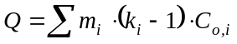 (2)

Table 4. Grouping of the alloys studied (Table 2) on the basis of growth restriction factor (Q).
Addition | Addition rate (%) | Group 1  (Q ~ 58 K) | Group 2  (Q ~ 75 K) | Group 3  (Q ~ 85 K) | Group 4  (Q ~ 95 K) | Group 5  (Q ~ 110 K)
- | – | A1 | A2, A3 | – | A4 | –
Al-5Ti-1B | 0.1 | – | – | A1 | – | –
Al-1.7Ti-1.7B | 0.05 | – | – | A2 | – | A4
 | 0.1 | – | – | – | A2 | A4
Al-5B | 0.05 | A1 | A2, A3 | – | A4 | –
 | 0.1 | A1 | A2, A3 | – | A4 | –
Al-2Nb-2B | 0.05 | A1 | A2, A3 | – | A4 | –
 | 0.1 | A1 | A2, A3 | – | A4 | –

The concept of growth restriction was further developed by Easton and St. John into a model to investigate and compare the grain refinement efficiency which relates the grain size (d) to the inverse of Q using a simple relationship:
d = a + b/Q (3)
where a is a constant connected to the maximum number of particles that can be successfully activated as nucleants and b is a constant related to the potency of the nucleant particles present into or intentionally added to the molten metal.
Fig. 7 illustrates the difference in grain size for the Q values groups listed in Table 4 and it can be noticed that, contrary to previous reports , for Al-Si alloys the grain size does not decreases with Q as “A4” (Q ~95) as coarser grains than “A1” (Q ~58). Moreover, there are significant variations within alloys with the same Q value and, generally, a higher addition of master alloy results in finer grain sizes at short inoculation time. At each Q value, the finest grain sizes are achieved using Nb-based heterogeneous substrates via the Al-2Nb-B master alloy, followed by the B-based particles (Fig. 7b and d). As per Fig. 7c, it is confirmed that Al-1.7Ti-1.7B (sub-stoichiometric) performs better than Al-5Ti-1B (hyper-stoichiometric). A remark should be made about Fig. 7a, B- and Nb-based master alloys show much more similar potency as, conversely to the other alloys, the “A1” alloy is Ti-free (Table 2). From this analysis is evident that the positive effect of adding different solutes via the master alloys is not exclusively due to the restriction imposed to the growing grains.
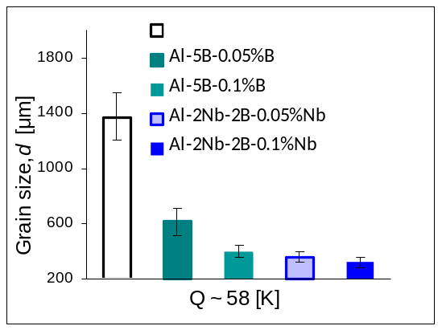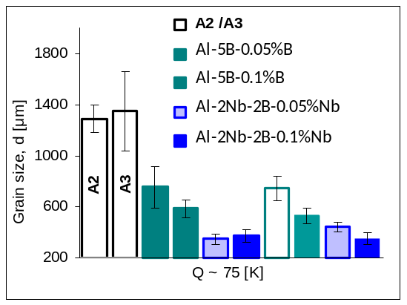
(a)
(b)
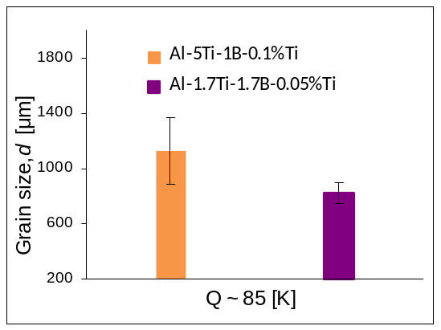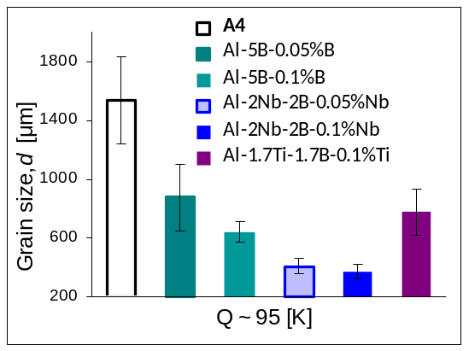
(c)
(d)
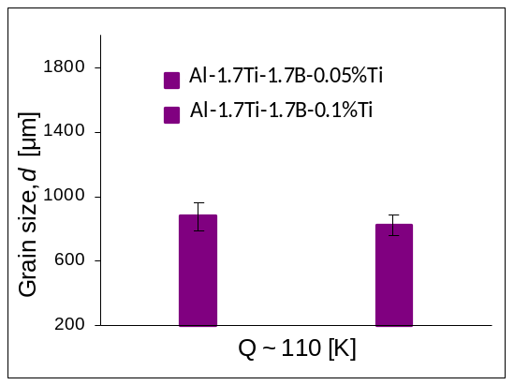
(e)
Fig. 7. Variation of the grain size (d) with Q (growth restriction factor): (a) Q ~ 58 K, (b) Q ~ 75 K, (c) Q ~ 85 K, (d) Q ~ 95 K, and (e) Q ~ 110 K.

To further elucidate the effect of the alloy chemistry, the variation of the mean grain size with the inverse of Q is shown in Fig. 8. It can be noticed that a linear trend is found for the alloys prior (squares) and after chemical inoculation. As per Eq. 3, the model developed by Easton and St. John predicts that the higher the Q value the finer the grain size. This is readily seen and achieved in wrought aluminum alloys, as data obtained from these types of alloys were used to develop the model. However, the data of Fig. 8 show grain coarsening with the Q value for both unrefined and refined alloys as the Q value is determined by the alloy chemistry as per Eq. 2. The data presented in Fig. 8 also indicate that the model can still be applied but, in the case of cast Al-Si alloys, the slope b is negative as the grain size increases for higher Q values. The difference in intercept a values suggest that different numbers of heterogeneous particles were active and triggered nucleation events. Generally lower a values are obtained with higher addition rates due to the presence of more particle acting as active nucleants.
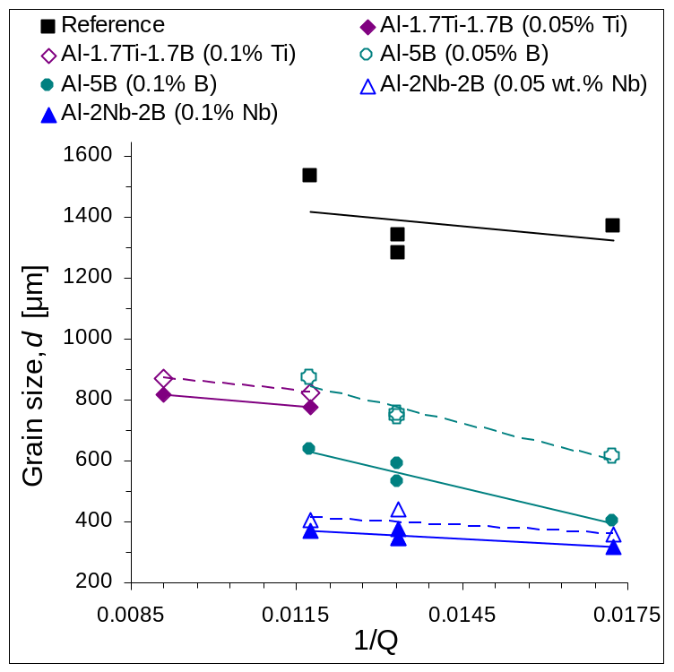
Fig. 8. Variation of the grain size (d) with 1/Q.

The values of the intercept a and slope b obtained via linear regression analysis of the data plotted in Fig 8 are reported in Table 5 confirming that different a values are obtained for different addition rates as the higher the addition rate the higher the number of potential active heterogeneous nucleation substrates.

Table 5. Values of the a and b parameters of Eq. 3 for Al-Si alloys without and with chemical inoculation.
Material | Addition rate | a | b | b (average)
Reference | – | 1625 | -17237 | –
Al-1.7Ti-1.7B | 0.05% Ti | 1046 | -19036 | -17595
Al-1.7Ti-1.7B | 0.1% Ti | 966 | -16154 | -17595
Al-5B | 0.05% B | 1361 | -44173 | -43527
Al-5B | 0.1% NB | 1135 | -42881 | -43527
Al-2Nb-2B | 0.05% Nb | 522 | -9555 | -9689
Al-2Nb-2B | 0.1% Nb | 489 | -9822 | -9689

It can also be noticed that slightly different values are reported in terms of the slope b as a function of the addition rate. This is mainly due to the highly heterogeneous non-equiaxed dendritic grains which lead to a high variance of the average values. Furthermore, the different average values of the slope b highlight that the master alloys, and therefore the inoculants present (i.e. TiB₂/Al₃Ti in Al-Ti-B, Al borides in Al-B, and NbB₂/Al₃Nb in Al-Nb-B as per Figure 5), have different potency. This is easily understandable for the Al-B master alloys, as Al borides have significantly different features (i.e. structure and lattice parameters) with respect to TiB₂ and NbB₂, and the grain size becomes coarser much faster with the increase of the Q value. Nevertheless, as per Figure 5 TiB₂/Al₃Ti in Al-Ti-B and NbB₂/Al₃Nb in Al-Nb-B are isomorphous and have similar lattice parameters and thus they could potentially have the same potency. The difference found is then most likely related to the poisoning of the inoculants once in contact with the molten Al-Si alloy.

5. Conclusions
From this study about the effect of boride particles and inoculation variables on the grain refinement of Al-Si alloys the following conclusions can be drawn:
1. Ti-, Al- and Nb-based boride and niobium aluminide particles can act as nucleation sites for α-Al but they have significantly different potency which, in most cases, is affected by the alloy chemistry and casting conditions. When the comparison of the potency of the master alloys is done considering a common element rather than the addition rate, sub-stoichiometric Al-Ti-B master alloys, generally, perform better than their hyper-stoichiometric counterparts.
2. Ti-based master alloys, containing TiB₂ and Al₃Ti, refine to some extent the cast structure of Al-Si alloys. However, the potency of the master alloys is rapidly lost due to poisoning as the contact time increases.
3. The addition of B-based master alloys grain refine Al-Si alloys. When the Al-Si alloy contains Ti as impurity, B-based and Ti-based master alloys show comparable potency and similarly cannot completely prevent the formation of columnar grains. For B-based master alloys, higher addition rates lead to finer grain sizes but there is also a greater influence from the casting conditions.
4. Nb-based master alloys consistently refine Al-Si alloy where the finest grain sizes are obtained when both Nb and B are present. The Al-7Nb master alloy has comparable potency to those of Ti- and B-based master alloys but the potency is not affected by the presence of the alloying elements such as Si or the contact time.
5. Alloy chemistry affects the level of refinement and a linear relationship between the grain size (d) and the inverse of the growth restriction factor (1/Q) is found but the slope b is negative as unrefined and refined cast Al-Si alloys are characterized by grain coarsening as Q increases.

Data Availability
All metadata pertaining to this work can be accessed via the following link: https:// (to be added in the accepted version)

Acknowledgements
The authors are thankful for the financial support from the Technology Strategy Board (TSB) through the TSB/101177 Project and to the Engineering and Physical Sciences Research Council (EPSRC) through the EP/J013749/1 and EP/K031422/1 Projects.

References
1. S. K. Shaha, F. Czerwinski, W. Kasprzak, J. Friedman and D. L. Chen, Journal of Alloys and Compounds, 2014, 615, 1019-1031.
2. M. A. Easton, M. Qian, A. Prasad and D. H. StJohn, Current Opinion in Solid State and Materials Science, 20 16, 20, 13-24.
3. R. Schmid-Fetzer and A. Kozlov, Acta Materialia, 2011, 59, 6133-6144.
4. M. Johnsson, Zeitschrift für Metallkunde, 1984, 85, 781-785.
5. G. S. V. Kumar, B. S. Murty and M. Chakraborty, Journal of Alloys and Compounds, 2009, 472, 112-120.
6. D. Qiu, J. A. Taylor, M. X. Zhang and P. M. Kelly, Acta Materialia, 2007, 55, 1447-1456.
7. V. E. Bazhenov and M. A. Magura, Materials Science and Technology, 2018, 34, 1287-1294.
8. A. L. Greer, The Journal of Chemical Physics, 2016, 145, 211704.
9. T. Wang, H. Fu, Z. Chen, J. Xu, J. Zhu, F. Cao and T. Li, Journal of Alloys and Compounds, 2012 511, 45-49.
10. Y. Birol, Materials Science and Technology, 2012, 28, 481-486.
11. L. Yu, X. Liu, Z. Wang and X. Bian, Journal of Materials Science, 2005, 40, 3865-3867.
12. H. Zhao, H. Bai, J. Wang and S. Guan, Materials Characterization, 2009, 60, 377-383.
13. P. Li, S. Liu, L. Zhang and X. Liu, Materials and Design, 2013, 47, 522-528.
14. Y. Birol, Journal of Alloys and Compounds, 2012, 513, 150-153.
15. Y. Birol, Materials Science and Technology, 2012, 28, 385-389.
16. A. N. Kolmogorov and S. Curtarolo, Physical Review B, 2006, 74, 224507.
17. X. Wang, Journal of Alloys and Compounds, 2017, 722, 302-306.
18. J. Li, G. Yang, F. S. Hage, Z. Chen, T. Wang, Q. M. Ramasse and P. Schumacher, Materials Characterization, 2017, 128, 7-13.
19. L. Bolzoni, M. Nowak and N. Hari Babu, Materials Science and Engineering A, 2015, 628, 230-237.
20. L. Bolzoni and N. Hari Babu, Journal of Materials Processing Technology, 2015, 222, 219-223.
21. L. Bolzoni and N. Hari Babu, Materials Letters, 2017, 201, 9-12.
22. L. Bolzoni, M. Nowak and N. Hari Babu, Journal of Alloys and Compounds, 2015, 623, 79-82.
23. Z. Chen, T. Wang, L. Gao, H. Fu and T. Li, Materials Science and Engineering A, 2012, 553, 32-36.
24. V. T. Witusiewicz, A. A. Bondar, U. Hecht and T. Y. Velikanova, Journal of Alloys and Compounds, 2009, 472, 133-161.
25. L. Bolzoni, M. Xia and N. Hari Babu, Scientific Reports, 2016, 6, 39554.
26. A. Cibula, The Journal of the Institute of Metals, 1951, 80, 1-16.
27. F. A. Crossley and L. F. Mondolfo, Journal of Metals (Trans. AIME), 1951, 191, 1143-1148.
28. G. P. Jones, J. Beech, H. Jones (Eds.), Solidification Processing, Sheffield: University of Sheffield, 1998, 496-497.
29. P. S. Mohanty and J. E. Gruzleski, Acta Metallurgica et Materialia, 1995, 43, 2001-2012.
30. I. Maxwell and A. Hellawell, Acta Metallurgica, 1975, 23, 229-237.
31. A. L. Greer, A. M. Bunn, A. Tronche, P. V. Evans and D. J. Bristow, Acta Materialia, 2000, 48, 2823-2835.
32. M. A. Easton and D. H. St. John, Acta Materialia, 2001, 49, 1867-1878.
33. Z. Chen, H. Kang, G. Fan, J. Li, Y. Lu, J. Jie, Y. Zhang, T. Li, X. Jian and T. Wang, Acta Materialia, 2016, 120, 168-178.
34. S. Nafisi and R. Ghomashchi, Materials Science and Engineering A, 2007, 452-453, 445-453.
35. X. Wang, Journal of Alloys and Compounds, 2005, 403, 283-287.
36. V. T. Witusiewicz, A. A. Bondar, U. Hecht, J. Zollinger, L. V. Artyukh and T. Y. Velikanova, Journal of Alloys and Compounds, 2009, 474, 86-104.
37. J. A. Spittle, Foundry Trade Journal, 2008, 335-340.
38. J. A. Spittle, Foundry Trade Journal, 2008, 308-314.
39. M. Easton and D. H. St. John, Metallurgical and Materials Transactions A, 1999, 30, 1613-1623.
40. M. Easton and D. St. John, Metallurgical Transactions A, 2005, 36, 1911-1920.
41. P. S. Mohanty and J. E. Gruzleski, Acta Materialia, 1996, 44, 3749-3760.

